

|  |
| --- |
| **Elevator Controller Design** |
| **26/06/2023** |

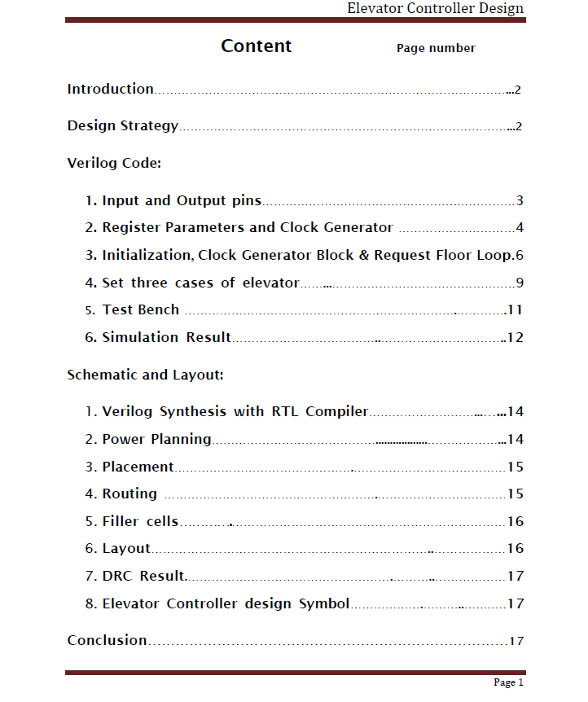

**Introduction**

This project is designed for an eight floor elevator controller. of an integrated circuit that can be used as part of elevator controller. The elevator decides moving direction by comparing request floor with current floor. In a condition that the weight has to be less than 450Kg and door has to be closed in three minute. If the weight is larger than it, the elevator will alert automatically. The Door Alert signal is normally low but goes high whenever the door has been open for more than three minute. There is a sensor at each floor to sense whether the elevator has passed the current floor. This sensor provides the signal that encodes the floor that has been passed.

The core parts of the design are shift register, three cases of elevator and the while loop when receive Request Floor.

**Design Strategy**

In the coding part, we used several strategies to make the program works.

First, we defined the input and output current floor as In_Current_Floor and Our_Current_Floor to avoid same variable name as output and input.

Second, we add two more input pins - Over_time and Over_Weight in the code. These signals will be output from the mechanical machine to the controller. When the controller receives signal from weight alert or door alert, the complete will become one so that the elevator will stay unmoved at the Out_Current_Floor.

Third, define the Out_Current_Floor, Direction, Complete, Door_Alert and Weight_Alert as reg then assign them equal to the output. Therefore, those variables will run as a register and output.

Next, when the Reset is off the variable Complete, Door Alert and Weight Alert will be initialized to be zero. Similary, when the Request_Floor is on, the variable In_Current_Floor is set to be equal to Out_Current_Floor only once.

Then, In_Current_Floor stay the same, Out_Current_Floor keep changing (updating) and compare with request floor, until Out_Current_Floor is at the same level as Request_Floor.

Lastly, define three cases of if statement for the elevator. There are cases for normal running cases – (comparing between Request_Floor and Out_Current_Floor to decide the moving direction), door open for more than three minutes - (turn on the Door_Alert) and overweight cases for elevator - (turn on the Weight_Alert).

**Verilog Code - Input and Output pins**

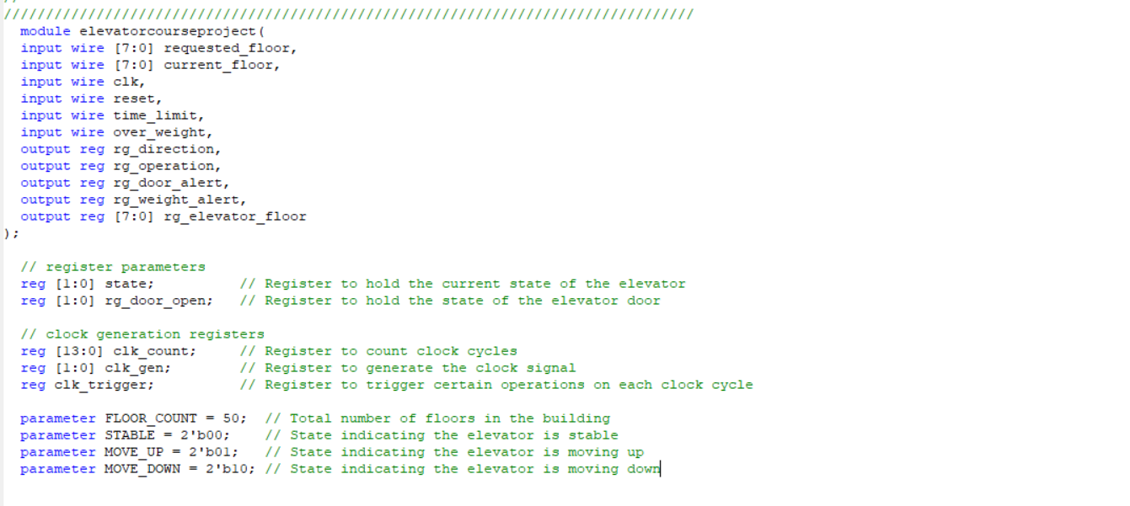

***Input [7:0] Request_Floor***

Define Request_Floor as 8-bit input variable. The 0 to 50 represent ground floor to 50 floor. (For example, second floor is 2, third floor is 3)

***Input [7:0] In_Current_Floor***

Define In_Current _Floor as 8-bit input variable. It represents the initial floor and the next complete floor (or the Out_Current _Floor that has reached the request floor).

***Input clk***

Define clk as input variable. To generate low frequency clock.

***Input reset***

Define reset as input variable. To generate reset.

***Input Over_time***

Define Over_time as input variable. In the Verilog code, “1” represents waiting time is longer than three minutes. Input Over_time will be the signal receives from timer (machinery part).

***Input Over_Weight***

Define Over_Weight as input variable. In the Verilog code, “1” represents elevator is overload. Input Over_Weight will be a signal receives from the weight detector (machinery part).

***Output Direction***

Define Direction as output variable. In the Verilog code, “1” represents moving up and “0” represents moving down.

***Output Complete***

Define Complete as output variable. In the Verilog code, “1” represents the elevator reaches the request floor. It can also represent pause (stay unmoved at the Out_Current_Floor), when the Over_Time or Weight_Alert is on.

***Output Door_Alert***

Define Door_Alert as output variable. In the Verilog code, “1” represents waiting time is longer than three minutes. Output Door_Alert will be on when Over_time is on.

***Output Weight_Alert***

Define Weight_Alert as output variable. In the Verilog code, “1” represents elevator is overload. Input Weight_Alert will on when Over_Weight is on.

***Output [7:0] Out_Current_Floor***

Define Out_Current _Floor as 8-bit output variable. It is a variable that will be used in the shift register.

**Verilog Code – Register Parameters and Clock Generator**

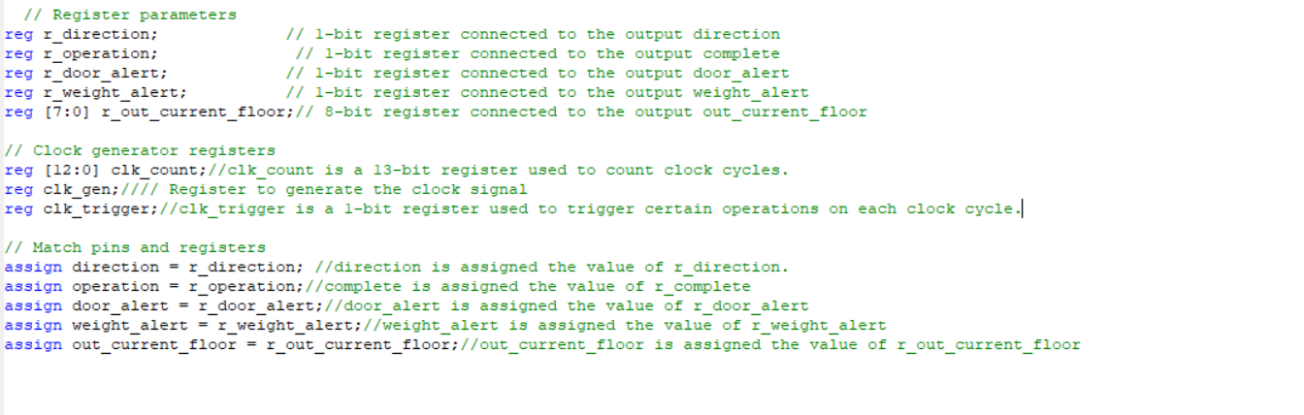

***Reg R_Direction***

Define R_Direction as register parameter. In the Verilog code, “1” represents moving up and “0” represents moving down.

***Reg R_Complete***

Define R_Complete as register parameter. In the Verilog code, “1” represents the elevator reaches the request floor. It can also represent pause.

***Reg R_Door_Alert***

Define R_Door_Alert as register parameter. In the Verilog code, “1” represents moving up and “0” represents moving down. Elevator Controller Design

***Reg R_Weight_Alert***

Define R_Door_Alert as register parameter. In the Verilog code, “1” represents elevator is overload.

***Reg [7:0] R_ Out_Current_Floor***

Define R_Out_Current_Floor as register parameter. In the Verilog code, “1” represents moving up and “0” represents moving down.

***Reg [12:0] CLK_Count***

Define CLK_Count as 12-bit register parameter. It is a low frequency clock counter.

***Reg CLK_200***

Define CLK_200 as register parameter. It generates a 200 Hz clock.

***Reg CLK_Trigger***

Define CLK_Trigger as register parameter. It is the trigger of generator clock.

***Assign Direction = R_Direction***

To store the data of R_Direction into Direction .

***Assign Direction Complete = R_Complete***

To store the data of Direction_Complete into R_Direction .

***Assign Door_Alert = R_Door_Alert***

To store the data of Door_Alert into R_Door_Alert.

***Assign Weight_Alert = R_Weight_Alert***

To store the data of Weight_Alert into R_ Weight _Alert

**Verilog Code – Initialization, Clock Generator Block and Request Floor Loop**



This part will do the Initialization of the r_complete, r_door_alert and r_weight_alert.

***Always @ (negedge reset)***

It will run only when the reset is zero. This loop will reset *CLK_200, CLK_Count and CLK_Trigger* to be zero*.* Also, the *R_Complete*, *R_Door_Alert* and *R_Weeight_Alert* will be set to be zero. If the reset is turn on to be one, the loop will not work.

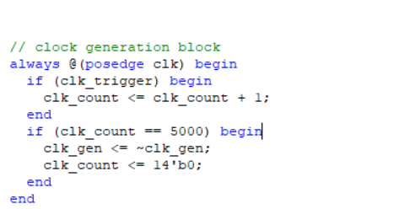

This is a clock generator that will run a loop when the *CLK* is on. The If Statement will determine whether the *CLK_Trigger* is on or the *CLK_Count* is equal to five thousand. If they are in the condition, the CLK_Count will increment every time the loop runs or the clock generator 200Hz will on. Therefore, the output control will run instantaneously.

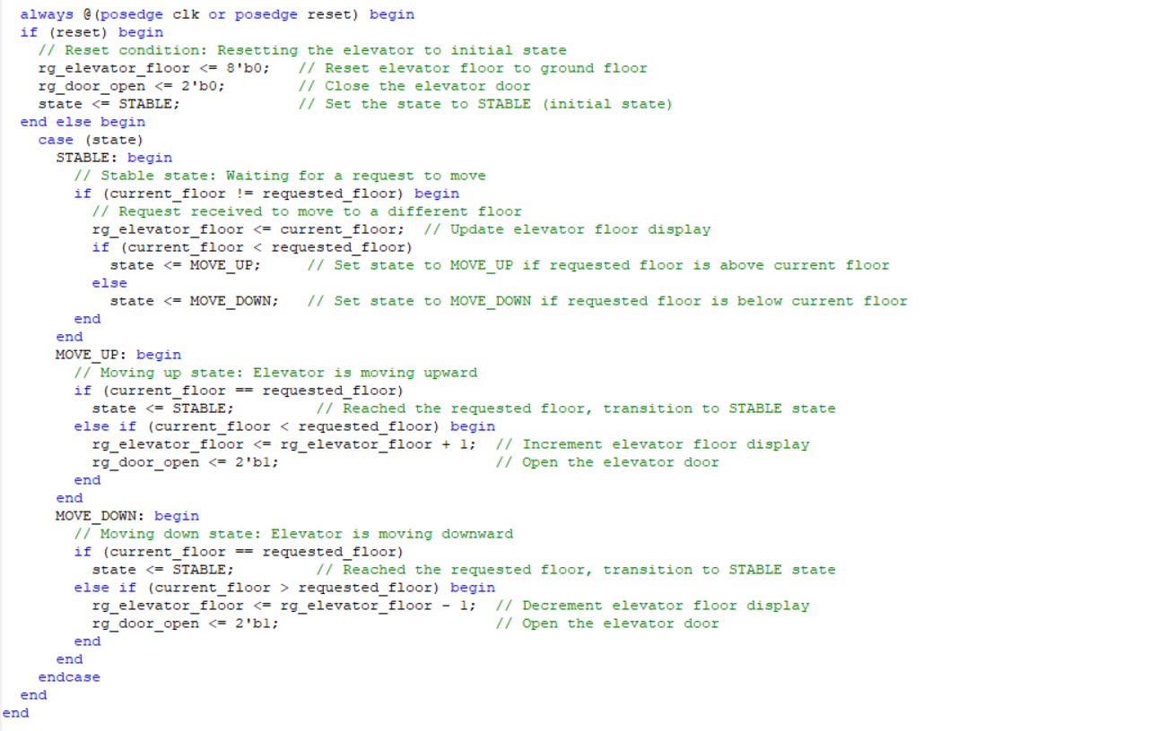

This is the core part of the design.

It stores the data of *In_Current_Floor* to *R*_*Out_Current_Floor* only once.

***Always @ (request_floor)***

The loop will run only when it receives request_floor.

It turn the *CLK_Trigger* on and trigger the 200Hz generator clock.

Also stores the data of *In_Current_Floor* to *R*_*Out_Current_Floor*.

Therefore, the *R*_*Out_Current_Floor* will be keep updating (or changing) whenever it reach the next floor, while the *In_Current_Floor* stay at the initial floor data.



**Current Floor**



**Over Weight**

**Door Alert**

**Request Floor**

**Direction**

**Current Floor**

This part will do the three cases of elevator. There are cases for normal running, door overtime and over load.

***Always @ (posedge clk)***

This loop will run only when the *CLK* is on.

***If (!reset && !over_time && !over_weight)***

This loop will run only in the condition that *reset*, *over_time* and *over_weight* are off.

**Case 1: the normal running case of elevator**

If the ***Request_Floor*** is **Greater** than ***R*_*Out_Current_Floor*** the elevator will move up.

If the ***Request_Floor*** is **Smaller** than ***R*_*Out_Current_Floor*** the elevator will move down.

If the ***Request_Floor*** is **Equal** to ***R*_*Out_Current_Floor*** (it reach the request floor**)** the ***R*_*Compelte*** is on and elevator stop moving

* The “<<1” and “>>1” are shift register. It shifts the data to the pointed direction by one. For example, “<<1” will move “1” to “2”.

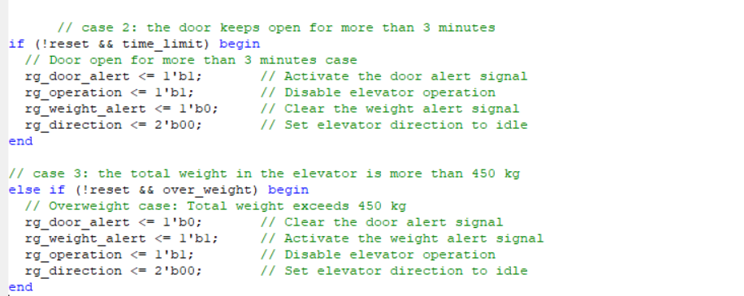

**Case 2: The door has been open for more than three minute**

If the ***Reset*** is off and ***Over_Time*** is on,

The ***R*_*Door_Alert*** and ***R*_*Complete*** are set to be ON

The ***R*_*Weight_Alert*** and ***R*_*Direction*** are set to be OFF

The ***R*_*Out_Current_Floor*** store its data to ***R*_*Out_Current_Floor***

Therefore the door alert ring and the elevator will stop moving (or pause) when it is over time.

**Case 3: the total weight in the elevator is more than 4500lb**

If the ***Reset*** is off and ***Over_Weight*** is on,

The ***R*_*Weight_Alert*** and ***R*_*Complete*** are set to be ON

The ***R*_*Door_Alert*** and ***R*_*Direction*** are set to be OFF

The ***R*_*Out_Current_Floor*** store its data to ***R*_*Out_Current_Floor***

Therefore the weight alert ring and the elevator will stop moving (or pause) when it is over load.

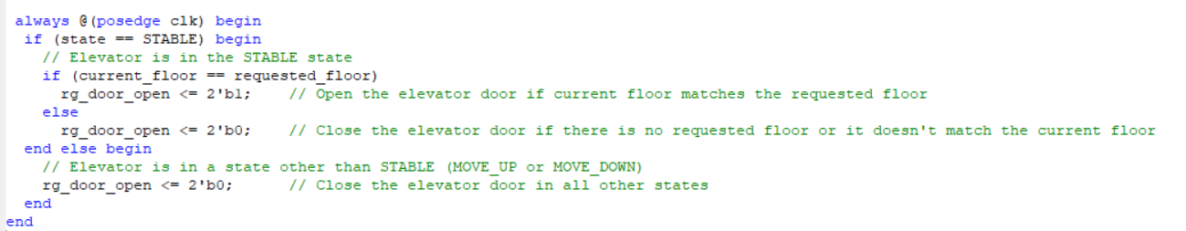

The behavior of the code block based on the elevator state and the current and requested floors. When the elevator is in the STABLE state, it checks if the current floor matches the requested floor and opens the elevator door accordingly. In all other states (MOVE_UP or MOVE_DOWN), the elevator door is closed.

**Verilog Test Bench Code**

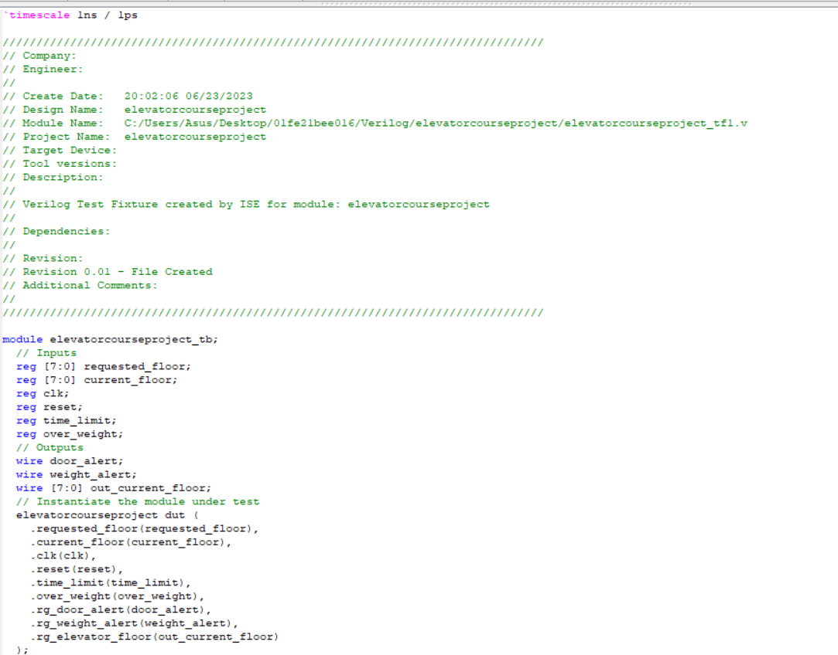

Inputs:

requested_floor: An 8-bit register representing the requested floor in the elevator.

current_floor: An 8-bit register representing the current floor of the elevator.

clk: A clock signal used to synchronize the operations of the module.

reset: A reset signal used to initialize the module and bring it to a known state.

time_limit: A signal indicating if the door has been open for more than 3 minutes.

over_weight: A signal indicating if the total weight in the elevator exceeds 450 kg.

Outputs:

door_alert: A wire indicating whether the door alert signal is active.

weight_alert: A wire indicating whether the weight alert signal is active.

out_current_floor: An 8-bit wire representing the current floor output of the elevator.

The elevatorcourseproject module is instantiated within the test bench using the dut instance name. The inputs and outputs of the test bench are connected to the corresponding inputs and outputs of the elevatorcourseproject module using port connections.

During simulation, the test bench initializes the inputs, generates a clock signal (clk), and applies stimulus to the inputs based on the desired test scenarios. The behavior of the elevatorcourseproject module is observed by monitoring the values of the output signals (door_alert, weight_alert, out_current_floor).

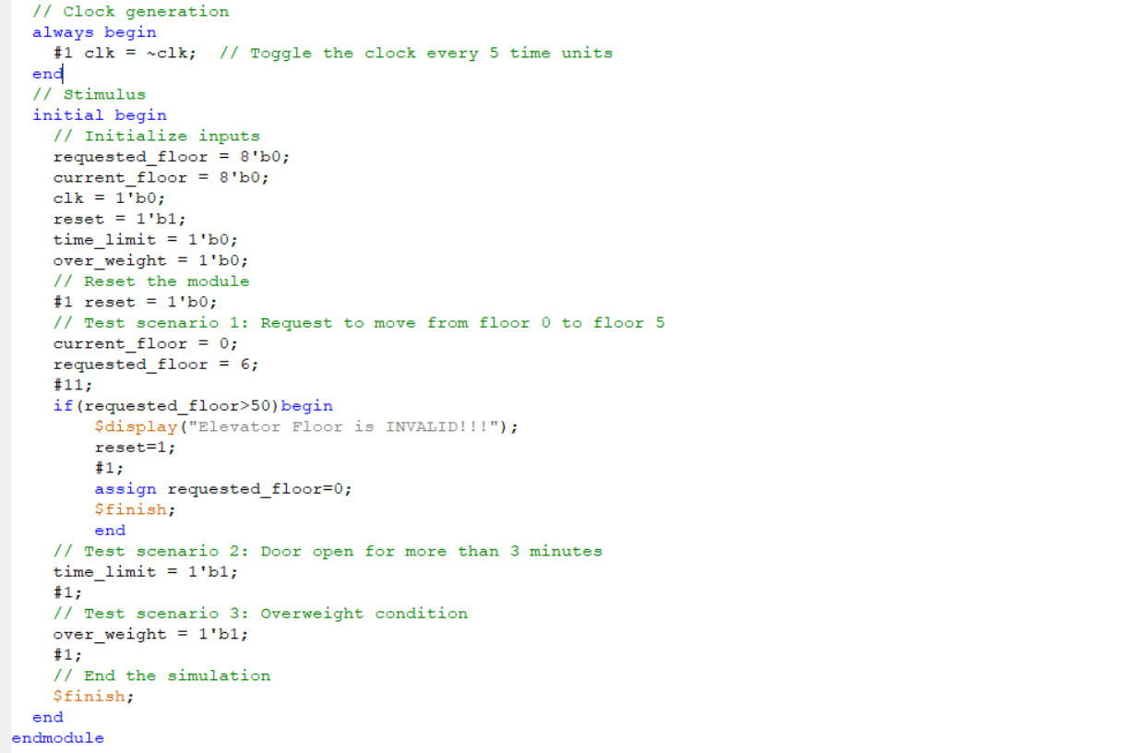

In the Verilog Test Bench Code, after we defined reg and wire variables, we chose only two cases to test our code, because there are more than fifty possible cases.

The two cases we chose are:

Request floor = 0; In_Current_floor = 6

The elevator will move down from sixth floor to ground floor.

**Simulation Result**

**When Request floor = 0; In_Current_floor = 6**

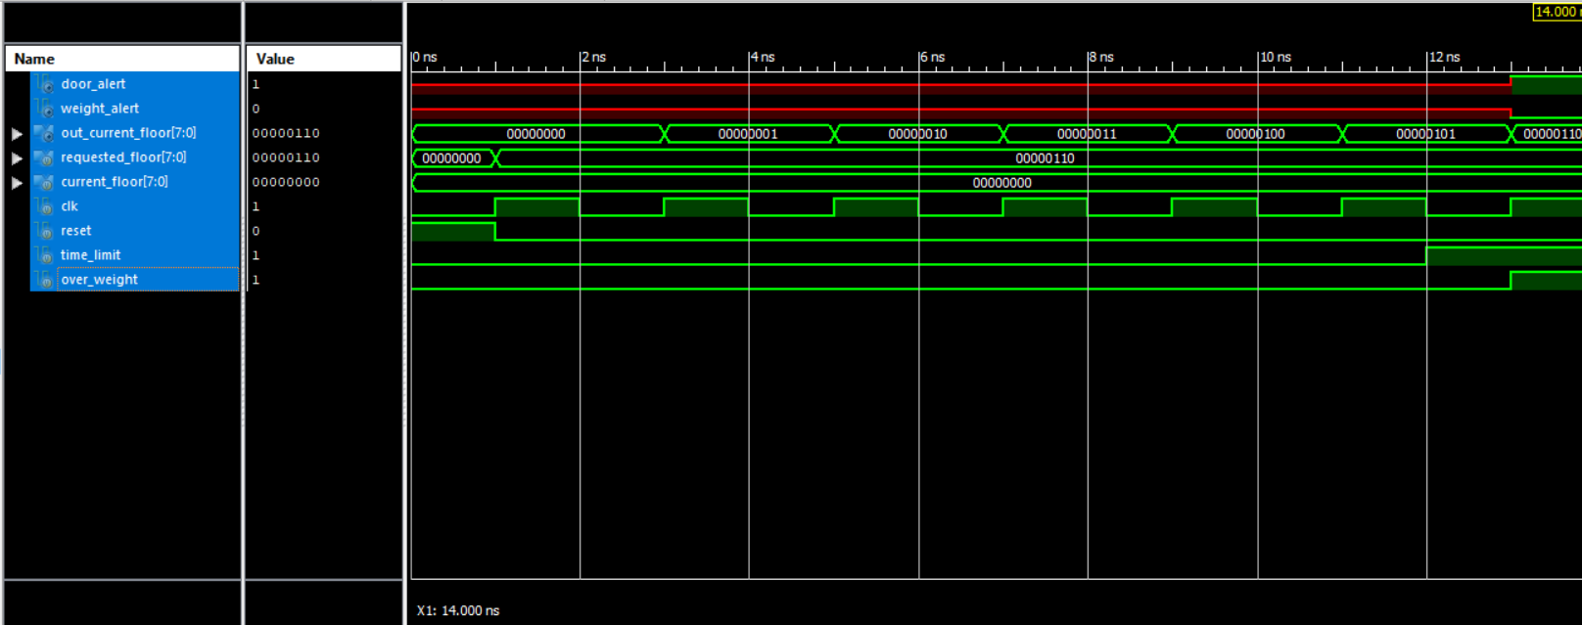

**Schematic and Layout**

**Verilog Synthesis with RTL Compiler**

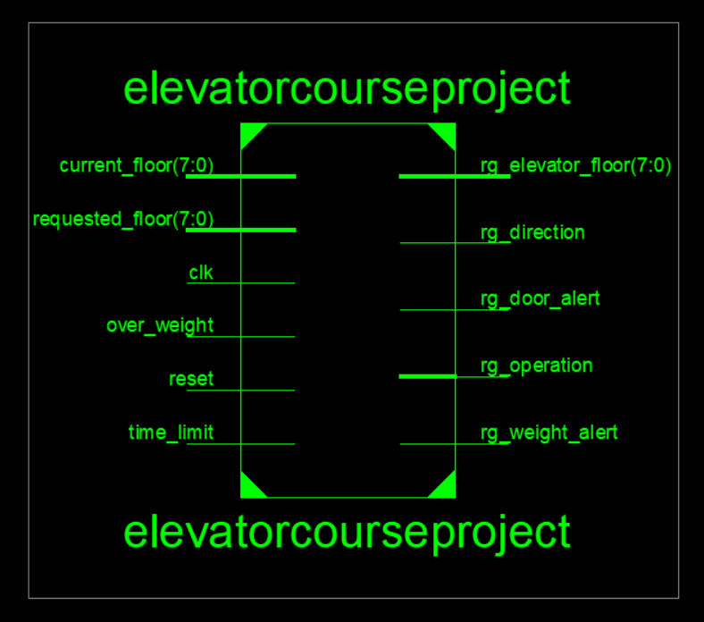

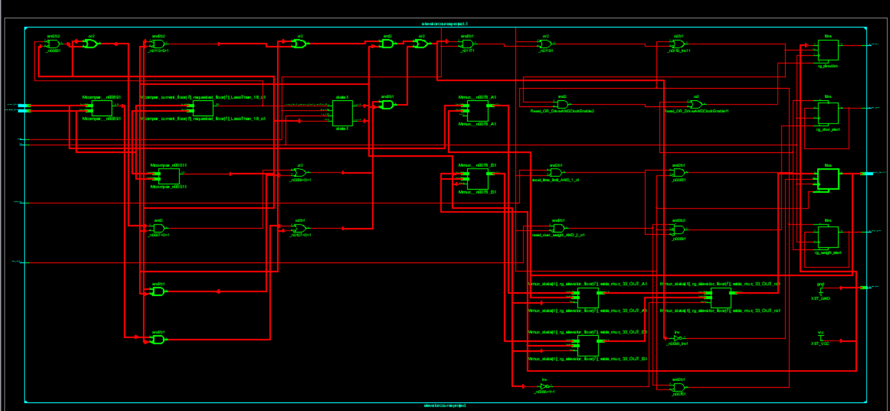

**Schematic and Layout**

**Verilog Synthesis with Technology Schematic Compiler**





**Power Planning**



**Placement**



**Routing**



**Filler Cells**



**Layout**



**Conclusion**

For this project, we learned the basic idea of how does the normal elevators run in many cases, even though it is simplified, we still spent lots of time to design and to figure out many problems when combining all the cases, of course the most challenging and time consuming part is debugging. However, after accomplishing it, we learned many things beyond this project, so it is a very helpful assignment.